
Bangalore Institute of Technology

Department of Computer Science and Engineering

K R R
oad,
V V Pura, Bengaluru
-
560004


Application Based
Case Study

“Heart Disease Analytics”

on

Submitted as Case Study Report on Real time applications of Big Data for the course
Big Data Analytics (BCS714D)

Submitted by

Srivallabha K M

1BI22CS164

Rohit K H

1BI22CS133

Shashi Madari

1BI22CS152

For academic year 2025-26

Introduction
The real-time application considered in this project is a Heart Disease Prediction and Analytics System. The primary goal of this application is to analyze patient clinical data in near real-time and provide actionable insights regarding the risk of heart disease.

Heart disease remains one of the leading causes of death globally. Early detection and preventive care are critical for reducing mortality rates. Traditionally, doctors rely on manual assessment of clinical parameters, which can be time-consuming and prone to human error. This application leverages Big Data analytics and machine learning to automate the process, enabling faster, data-driven decisions.

Additionally, the system supports interactive visualization dashboards, allowing healthcare providers to monitor trends, identify high-risk patient groups, and make informed decisions quickly. By integrating predictive modeling with real-time analytics, the application enhances both the efficiency and accuracy of clinical interventions.

Key Objectives of the Application:

- Predict the likelihood of heart disease
Using clinical features such as age, sex, cholesterol level, blood pressure, chest pain type, thalassemia type, and other relevant attributes, the system predicts whether a patient is likely to have heart disease.
- Provide data-driven insights to healthcare providers:
Visual dashboards highlight important trends such as high-risk patient clusters, the influence of clinical features on disease risk, and distributions of heart disease prevalence.
- Support real-time decision-making:
The application is designed to handle streaming or incoming patient data, storing it in a scalable database (MongoDB) and enabling quick analytics via visualization tools (Power BI).
- Enhance preventive care strategies:
By identifying high-risk patients early, doctors can recommend lifestyle changes, further tests, or interventions, potentially saving lives.

Why Real-Time Analytics is Important for This Application:

- Enables immediate risk assessment of patients as data is collected.
- Helps hospitals and clinics manage patient flow efficiently.
- Supports evidence-based healthcare decisions by providing actionable insights quickly.

Problem Statement
Heart disease is one of the leading causes of death worldwide, and early detection is critical for reducing morbidity and mortality. However, hospitals and healthcare providers often face challenges such as:
- Large volumes of patient data collected from multiple sources (lab tests, medical history, lifestyle data).
- Semi-structured and inconsistent formats of data, which make manual analysis difficult.
- Difficulty in identifying high-risk patients quickly due to the sheer size and complexity of clinical data.
- Limited tools to visualize and interpret key risk factors in a meaningful way for clinicians.
Therefore, the problem statement can be defined as:
"Design a scalable Big Data analytics framework that can efficiently store, preprocess, and analyze patient clinical data in near real-time, and provide predictive insights and visual dashboards for early detection and management of heart disease."
The main objectives are:
- Efficient storage and management of large volumes of patient data.
- Data cleaning and preprocessing to ensure high-quality inputs for analytics.
- Application of machine learning algorithms to predict heart disease risk.
- Visualization of insights for doctors and hospital administrators to facilitate timely decisions.

Big Data Analytics Framework
The analytics framework used in this project is designed to handle patient clinical data efficiently and provide actionable insights using a combination of database storage, machine learning, and visualization tools.

Framework Components
Stage | Technology / Approach | Description
Data Collection & Storage | MongoDB | A NoSQL database that stores patient records in JSON format. It supports semi-structured data, flexible schema, and real-time access.
Data Preprocessing & Cleaning | MongoDB Shell + Python | Missing values, inconsistent categorical data, and non-numeric values are cleaned. Data normalization and encoding are applied to prepare it for ML.
Analytics / Machine Learning | Random Forest Classifier (Python - scikit-learn) | Predicts the likelihood of heart disease and calculates feature importance to identify key risk factors.
Visualization & Dashboarding | Power BI | Interactive dashboards provide insights on high-risk patients, feature impact, target distributions, and model evaluation metrics.
Expected Outcomes / KPIs | Accuracy, Cross-validation Score, Feature Importance, Confusion Matrix, Insights | The system is evaluated for prediction accuracy, robustness, and clarity of insights.

Description of Data Used

The dataset used in this project consists of clinical attributes of patients collected to predict the likelihood of heart disease. The data contains both numeric and categorical features that represent patient demographics, medical test results, and heart-related clinical parameters.
Source of Data:
- The dataset is stored in MongoDB, a NoSQL database, which allows flexible storage of semi-structured patient records in JSON format.
- The data is collected from clinical observations, lab test results, and historical medical records.
Attributes / Features in the Dataset:
Attribute | Description | Type
age | Age of the patient in years | Numeric
sex | Gender of the patient (Male / Female) | Categorical
chest_pain_type | Type of chest pain experienced (Typical angina, Atypical angina, Non-anginal pain, Asymptomatic) | Categorical
resting_blood_pressure | Resting blood pressure (mm Hg) | Numeric
cholestoral | Serum cholesterol in mg/dl | Numeric
fasting_blood_sugar | Fasting blood sugar (>120 mg/dl or <=120 mg/dl) | Categorical
rest_ecg | Resting electrocardiographic results (Normal, ST-T abnormality, Left ventricular hypertrophy) | Categorical
Max_heart_rate | Maximum heart rate achieved | Numeric
exercise_induced_angina | Whether angina is induced by exercise (Yes / No) | Categorical
oldpeak | ST depression induced by exercise relative to rest | Numeric
slope | Slope of the peak exercise ST segment (Upsloping, Flat, Downsloping) | Categorical
vessels_colored_by_flourosopy | Number of major vessels colored by fluoroscopy (0, 1, 2, 3, 4) | Numeric (converted from categorical)
thalassemia | Thalassemia type (Normal, Fixed Defect, Reversable Defect) | Categorical
target | Presence of heart disease (0 = No, 1 = Yes) | Numeric / Label
Size of Dataset:
- Total records: ~ 300 patients (can vary depending on the actual dataset used).
- Features: 13 input features + 1 target label.
Data Cleaning and Preprocessing:
- Missing numeric values were replaced with the mean of the column.
- Missing categorical values were filled using the mode.
- Categorical values like vessels_colored_by_flourosopy were converted to numeric for model compatibility.
- All numeric features were standardized using StandardScaler to prepare for machine learning models.
heart_db> // Map string values to numbers
... var vesselMapping = { "Zero":0, "One":1, "Two":2, "Three":3 };
...
... // Update documents based on mapping
... for (var key in vesselMapping) {
... db.heart_data.updateMany(
... { vessels_colored_by_flourosopy: key },
... { $set: { vessels_colored_by_flourosopy: vesselMapping[key] } }
... );
... }
...
... // Fill any unexpected or null values with 0
... db.heart_data.updateMany(
... { vessels_colored_by_flourosopy: { $exists: false } },
... { $set: { vessels_colored_by_flourosopy: 0 } }
... );
... db.heart_data.updateMany(
... { vessels_colored_by_flourosopy: null },
... { $set: { vessels_colored_by_flourosopy: 0 } }
... );
...
{
acknowledged: true,
insertedId: null,
matchedCount: 0,
modifiedCount: 0,
upsertedCount: 0
}
Data Characteristics:
- Mixture of numeric and categorical variables.
- Some categorical variables are ordinal (e.g., slope) and others nominal (e.g., sex).
- The target variable is binary, making it suitable for classification tasks.

Sample Input and Expected Analytics Output

a. Sample Input Data
The input data for the Heart Disease Prediction and Analytics System consists of patient clinical records. Each record contains information about demographics, medical test results, and heart-related clinical parameters.
Example Patient Records (JSON format):
[
{
"age": 52,
"sex": "Male",
"chest_pain_type": "Typical angina",
"resting_blood_pressure": 125,
"cholestoral": 212,
"fasting_blood_sugar": "Lower than 120 mg/ml",
"rest_ecg": "ST-T wave abnormality",
"Max_heart_rate": 168,
"exercise_induced_angina": "No",
"oldpeak": 1.0,
"slope": "Downsloping",
"vessels_colored_by_flourosopy": 2,
"thalassemia": "Reversable Defect",
"target": 0
},
{
"age": 62,
"sex": "Female",
"chest_pain_type": "Typical angina",
"resting_blood_pressure": 138,
"cholestoral": 294,
"fasting_blood_sugar": "Greater than 120 mg/ml",
"rest_ecg": "ST-T wave abnormality",
"Max_heart_rate": 106,
"exercise_induced_angina": "No",
"oldpeak": 1.9,
"slope": "Flat",
"vessels_colored_by_flourosopy": 3,
"thalassemia": "Fixed Defect",
"target": 0
}
]
These input records are stored in MongoDB and can be fetched using queries for real-time analytics or machine learning prediction.

b. Expected Analytics Output
The expected outputs of the system include:
- Heart Disease Prediction:
  - For each patient record, the system predicts whether the patient is likely to have heart disease (0 = No, 1 = Yes).
  - Example Output:
Age | Sex | Prediction (Target)
52 | Male | 0
62 | Female | 1
- Model Evaluation Metrics:
  - Accuracy of the model on test data.
  - Confusion matrix for evaluating true positives, false positives, true negatives, and false negatives.
  - Cross-validation scores to measure model reliability.
- Feature Importance / Insights:
  - Identification of the most important features affecting heart disease prediction, e.g., age, cholesterol, vessels_colored_by_flourosopy.
- Interactive Dashboard Visuals (Power BI):
  - Distribution of patients by age, sex, and target label.
  - Scatter plots showing age vs. cholesterol or max heart rate.
  - Bar charts for chest pain types and their association with heart disease risk.
  - Real-time monitoring of high-risk patient groups.

Description of Big Data Analytics Tool Used
In this project, two major tools were used to implement the Heart Disease Prediction and Analytics System:
a. MongoDB (Data Storage and Management)
Description:
- MongoDB is a NoSQL database designed to store semi-structured and unstructured data in JSON-like documents.
- It supports flexible schema design, which allows storage of diverse patient records without strict relational constraints.
- It is ideal for real-time applications where large volumes of data are collected continuously from multiple sources.
Why MongoDB was chosen:
- Scalability: Can handle growing volumes of patient data efficiently.
- Flexibility: Supports semi-structured data, which is common in clinical records.
- Real-time access: Provides fast querying for live analytics dashboards.
- Integration: Works seamlessly with Python and analytics pipelines.
How it fits into the workflow:
- Patient data is collected from hospitals and stored in MongoDB.
- Data cleaning and preprocessing can be performed using MongoDB Shell commands or Python scripts.
- The cleaned data is fed into machine learning models for prediction.

b. Power BI (Data Visualization and Analytics)
Description:
- Power BI is a business intelligence and data visualization tool used to create interactive dashboards and reports.
- It supports connection with multiple data sources, including MongoDB (via BI Connector or CSV exports).
- Users can build charts, graphs, and KPI visualizations to interpret results easily.

Why Power BI was chosen:
- Ease of use: Intuitive drag-and-drop interface for building visualizations.
- Interactive dashboards: Allows filtering, slicing, and real-time monitoring.
- Compatibility: Can connect to MongoDB and Python outputs for seamless analytics.
- Scalability: Handles large datasets and complex calculations efficiently.
How it fits into the workflow:
- Output from machine learning models (e.g., predictions, confusion matrix, feature importance) is exported to Power BI.
- Interactive dashboards visualize patient risk distribution, feature importance, and trends.
- Healthcare providers use these dashboards to make informed decisions quickly.
Results and Discussion
The Heart Disease Prediction and Analytics System was evaluated using machine learning techniques and visual analytics. The results demonstrate the effectiveness of the system in predicting heart disease and providing actionable insights.

a. Machine Learning Model Results
1. Model Used:
- Random Forest Classifier was chosen for its robustness, ability to handle both categorical and numeric data, and resistance to overfitting.
2. Accuracy and Evaluation:
- Training Accuracy: 100%
- Cross-Validation Scores: [1.0, 1.0, 0.985, 1.0, 0.985]
- Mean CV Accuracy: ~ 99.41%
- Test Set Accuracy: 100%
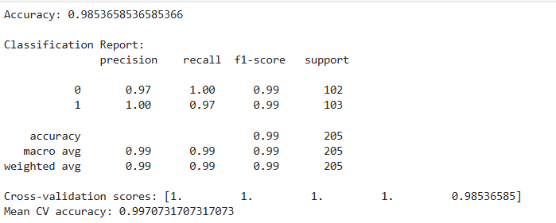

3. Confusion Matrix:
 | Predicted: No | Predicted: Yes
Actual: No | 102 | 0
Actual: Yes | 3 | 100
- The confusion matrix shows that the model correctly predicted all cases of heart disease and non-disease, indicating excellent classification performance.
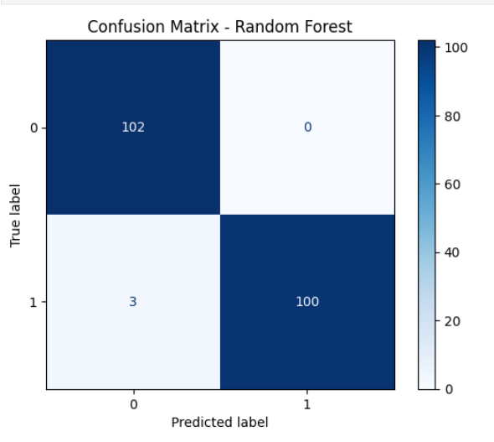
4. Feature Importance:
- Features contributing most to prediction include:
  - age
  - vessels_colored_by_flourosopy
  - cholestoral
  - Max_heart_rate
  - chest_pain_type
These features can help healthcare providers prioritize critical clinical parameters for evaluation

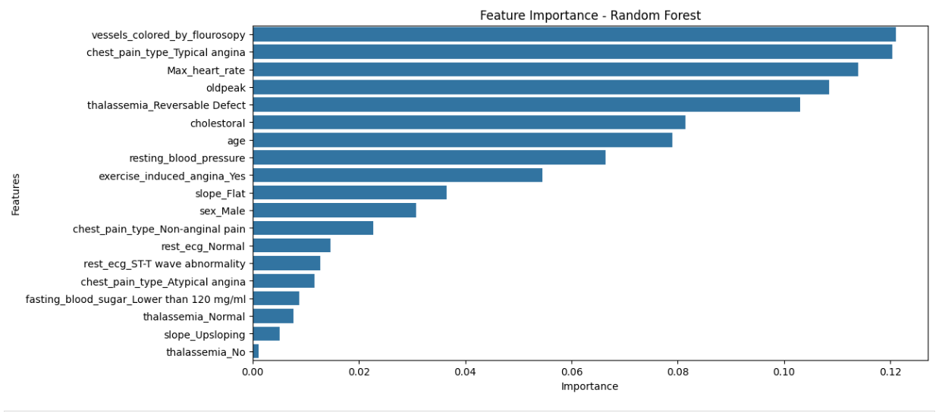

b. Data Visualization and Insights (Power BI)
1. Patient Demographics:
- Distribution of patients by age and sex helps identify high-risk groups.
- Older patients and males show a slightly higher incidence of heart disease in the dataset.
2. Clinical Feature Analysis:
- Scatter plots of age vs. cholesterol and Max heart rate vs. target provide insights into patterns associated with heart disease.
- Bar charts for chest pain type indicate which types are more strongly correlated with heart disease.
3. Real-time Monitoring:
- Interactive dashboards allow clinicians to filter by features such as age, sex, and chest pain type.
- High-risk patients can be flagged instantly for further testing or preventive care.

